**CS5560 Knowledge Discovery Management**

**LAB ASSIGNMENT #1**

**Lab Submission through the following link before June 13, 2017 (T) 11:59PM.**

<https://goo.gl/forms/eGLZpAZwQYimFlI03>

1. **Generate the following NLP tasks for the following sentence manually**

***Input***:

* 1. The dog saw John in the park

**NLP Tasks:**

*Part-of-speech (POS) tagger:*

The/DT

dog/NN

saw/VBD

John/NNP

in/IN

the/DT

park/NN

*Named entity recognizer (NER):*

The dog saw John in the park

*Person*

*Co-reference resolution system*

------------

* 1. The little bear saw the fine fat trout in the rocky brook.

**NLP Tasks:**

*Part-of-speech (POS) tagger:*

The/DT

little/JJ

bear/NN

saw/VBD

the/DT

fine/JJ

fat/JJ

trout/NNS

in/IN

the/DT

rocky/JJ

brook/NN

*Named entity recognizer (NER):*

The little bear saw the fine fat trout in the rocky brook

Place

*Co-reference resolution system:*

--------------

1. **Create a** **NLP project for the following tasks using Core NLP**

***Input***: Choose Dataset from the sheets

***NLP Tasks:***

1. *Part-of-speech (POS) tagger*
2. *Named entity recognizer (NER)*
3. *Co-reference resolution system*
4. *Sentiment Analysis*
5. **Create a simple question answering system as an extension of the dataset and tasks done in (2). *(Take home assignment)***

**Additional Guidelines:**

1. Use the Question Type (https://en.wikipedia.org/wiki/Interrogative_word). Suggestions are When, Who, What.

Also refer to the **Yahoo Question Answering System** Demo: https://answers.yahoo.com/

1. The three steps are the below diagram is going to be basic idea of your Q&A System

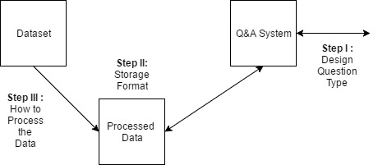

1. Start with Step 1 for the System, it will be easier to process data based on the question.